Green River College

Final Project

School Scores Database

Blezyl Santos

IT 201 Database Fundamentals

December 11, 2019

Analysis

The school score database shows the amount of test takers and average math and verbal scores for the SAT test. The database consists of scores from all states in the USA for each year from 2005 to 2015. There are 7 look-up table containing a name or description and a corresponding id. The look-up tables are *family-income-range*, *gpas*, *score_range,* *types, subjects, state*, and *year*. There are also 6 linking tables that consists of foreign keys from the look-up tables and contains the results (i.e. verbal and math score, and test takers). The linking tables are *Fam_income_scores, gpa_scores, score_range_students, gender_scores, subject_averages,* and *score*. The gpa_scores table is the only table that does not have average math and verbal scores and test takers, but it does have average gpa and average year.

As a student, it is interesting to see how other students have done on the same test. Also, this dataset includes other factors other than GPAs, it includes family income, gender, and all of the states spanning 10 years.

Questions

1. Display the scores of states that contain the word “New” and has an Average Math score between 550-600
2. Display the top 5 Average Verbal scores and years of Texas with a GPA of “A+”, “A-”, or “A.”
3. Show the States and average female math scores that are more than the average score of males in 2015.
4. What Family income range has the most test takers in California on 2010.
5. Show the state, average gpa, average verbal score for the highest average GPA in the subject of “Arts/Music” for each year.
6. Show the Total number of male students in each score range on 2013 that is greater than 5000.

Design

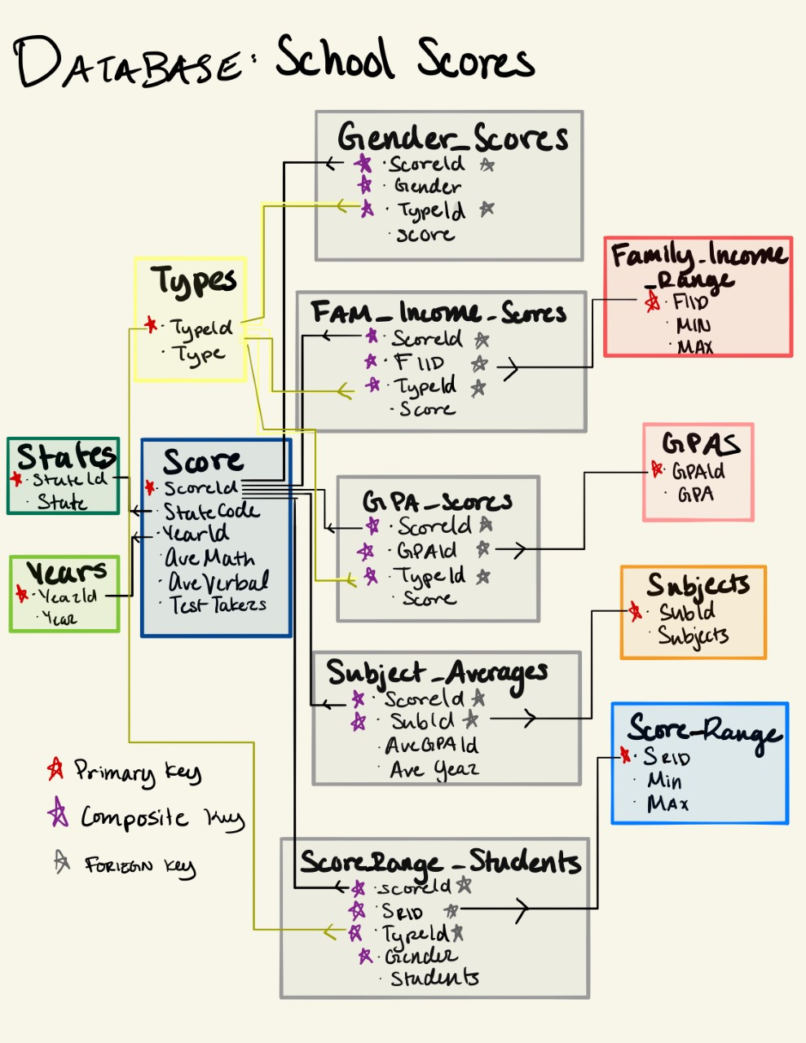

Implementation

Table for original database

CREATE TABLE schoolscores (

id int(4) NULL NULL PRIMARY KEY AUTO_INCREMENT,

year year,

staeCode char(2),

state varchar(30),

AveMath int(3),

AveVerbal int(3),

TestTakers int(7),

AcaArtGPA decimal(3,2),AcaArtYear decimal(3,2),

AcaEngGPA decimal(3,2),AcaEngYear decimal(3,2),

AcaForeignGPA decimal(3,2), AcaForeignYear decimal(3,2),

AcaMathGPA decimal(3,2),AcaMathYear decimal(3,2),

AcaNatGPA decimal(3,2)AcaNatYear decimal(3,2),

AcaSocGPA decimal(3,2),AcaSocYear decimal(3,2),

fi2M int(3),fi2t int(5),fi2v int(3),

fi4M int(3),fi4t int(5),fi4v int(3),

fi6M int(3),fi6t int(5),fi6v int(3),

fi8M int(3),fi8t int(5),fi8v int(3),

fi0M int(3),fi0t int(5),fi0v int(3),

fi1M int(3),fi1t int(5),fi1v int(3),

gpa_amM int(3),gpa_amT int(5),gpa_amV int(3),

gpa_apM int(3),gpa_apT int(5),gpa_apV int(3),

gpa_aM int(3),gpa_aT int(5),gpa_aV int(3),

gpa_bM int(3),gpa_bT int(5),gpa_bV int(3),

gpa_cM int(3),gpa_cT int(5),gpa_cV int(3),

gpa_dM int(3),gpa_dT int(5),gpa_dV int(3),

gpa_nM int(3),gpa_nT int(5),gpa_nV int(3),

genderFM int(3),genderFT int(5),genderFV int(3),

genderMM int(3),genderMT int(5),genderMV int(3),

scr2MF int(4),scr2MM int(4),scr2MT int(4),

scr2vF int(4),scr2vM int(4),scr2vT int(4),

scr3MF int(4),scr3MM int(4),scr3MT int(4),

scr3vF int(4),scr3vM int(4),scr3vT int(4),

scr4MF int(4),scr4MM int(4),scr4MT int(4),

scr4vF int(4),scr4vM int(4),scr4vT int(4),

scr5MF int(4),scr5MM int(4),scr5MT int(4),

scr5vF int(4),scr5vM int(4),scr5vT int(4),

scr6MF int(4),scr6MM int(4),scr6MT int(4),

scr6vF int(4),scr6vM int(4),scr6vT int(4),

scr7MF int(4),scr7MM int(4),scr7MT int(4),

scr7vF int(4),scr7vM int(4),scr7vT int(4)

)

7 look-up tables

--------------------------------------------------------------------------

CREATE TABLE states (

stateCode char(2) NOT NULL PRIMARY KEY,

state varchar(30)

)

INSERT INTO states (states.stateCode, states.state) SELECT DISTINCT schoolscores.staeCode, schoolscores.state FROM schoolscores

--------------------------------------------------------------------------

CREATE TABLE years(

yearId int(2) NOT NULL PRIMARY KEY AUTO_INCREMENT,

year year

)

INSERT INTO years (year) SELECT DISTINCT schoolscores.year FROM schoolscores

--------------------------------------------------------------------------

CREATE TABLE types(

typeId int(2) NOT NULL PRIMARY KEY AUTO_INCREMENT,

type VARCHAR(10)

)

INSERT INTO types(type) VALUES ("Math"), ("Verbal"), ("Test-Takers")

--------------------------------------------------------------------------CREATE TABLE family_income_range(

fiid int(1) NOT NULL PRIMARY KEY AUTO_INCREMENT,

min int(3),

max int(3)

)

INSERT INTO family_income_range (min, max) VALUES (0,20),(20,40),(40,60),(60,80), (80,100), (100,999)

--------------------------------------------------------------------------

CREATE TABLE gpas(

gpaid int(1) NOT NULL PRIMARY KEY AUTO_INCREMENT,

gpa char(15)

)

INSERT INTO gpas(gpa) VALUES ("A+"), ("A"), ("A-"),("B"),("C"),("D or Lower"), ("No response")

--------------------------------------------------------------------------

CREATE TABLE score_range(

srid int(1) NOT NULL PRIMARY KEY AUTO_INCREMENT,

min int(3),

max int(3)

)

INSERT INTO score_range (min, max) VALUES (200,300),(300,400),(400,500),(500,600),(600,700), (700,800)

--------------------------------------------------------------------------

CREATE TABLE subjects(

subid int(1) NOT NULL PRIMARY KEY AUTO_INCREMENT,

subject varchar(30)

)

INSERT INTO subjects (subject) VALUES

("Arts/Music"),("English"),("Foreign Language"),("Mathematics"),("Natural Science"),("Social Science")

--------------------------------------------------------------------------

6 Linking tables

Only included one insert-update statement to reduce pages. To insert more data from the original table, change the where clause and the column name from schoolscores

(e.g.

INSERT ...

where fiid = 1 AND typeid = 1;

UPDATE ...

SET Fam_income_scores.score = schoolscores.fi0M

where fiid = 1 AND typeid = 1 ;

to

INSERT ...

where fiid = *4* AND typeid = *3*;

...

UPDATE ...

SET Fam_income_scores.score = schoolscores.*fi6T*

where fiid = *4* AND typeid = *3* ;

)

--------------------------------------------------------------------------

CREATE TABLE Fam_income_scores(

scoreId int(3),

fiid int(1),

typeId int(2),

score int(7),

FOREIGN KEY (scoreId) REFERENCES score(scoreId),

FOREIGN KEY (typeId) REFERENCES types(typeId),

FOREIGN KEY (fiid) REFERENCES family_income_range(fiid),

PRIMARY KEY (scoreId, fiid, typeid)

)

INSERT INTO Fam_income_scores (scoreid, fiid, typeId)

SELECT DISTINCT score.scoreId, family_income_range.fiid, types.typeId

FROM score, family_income_range, types

where fiid = 1 AND typeid = 1

ORDER BY `score`.`scoreId` ASC;

UPDATE Fam_income_scores

INNER JOIN score ON

score.scoreId=Fam_income_scores.scoreId

INNER JOIN years ON

years.yearId = score.yearsId

INNER JOIN schoolscores ON

score.stateCode = schoolscores.staeCode AND

years.year = schoolscores.year

SET Fam_income_scores.score = schoolscores.fi0M

where fiid = 1 AND typeid = 1;

...

--------------------------------------------------------------------------

CREATE TABLE gpa_scores(

scoreId int(3),

gpaid int(1),

typeId int(2),

score int(7),

FOREIGN KEY (scoreId) REFERENCES score(scoreId),

FOREIGN KEY (gpaId) REFERENCES gpas(gpaId),

FOREIGN KEY (typeid) REFERENCES types(typeId),

PRIMARY KEY (scoreId, gpaid, typeid)

)

INSERT gpa_scores(scoreId, gpaid, typeid)

SELECT DISTINCT score.scoreId, gpas.gpaid, types.typeId

FROM score, gpas, types

WHERE gpaid = 1 and typeid = 1;

UPDATE gpa_scores

INNER JOIN score ON

score.scoreId=gpa_scores.scoreId

INNER JOIN years ON

years.yearId = score.yearsId

INNER JOIN schoolscores ON

score.stateCode = schoolscores.staeCode AND

years.year = schoolscores.year

SET gpa_scores.score = schoolscores.gpa_apM

WHERE gpaid = 1 and typeid = 1;

...

--------------------------------------------------------------------------

CREATE TABLE score_range_students(

scoreId int(3),

srid int(1),

typeid int(2),

gender varchar(10),

students int(5),

FOREIGN KEY (scoreId) REFERENCES score(scoreId),

FOREIGN KEY (srid) REFERENCES score_range(srid),

FOREIGN KEY (typeid) REFERENCES types(typeid),

PRIMARY key (scoreid, srid, typeid, gender)

)

​INSERT INTO score_range_students(scoreId, srid, typeid, gender)

SELECT DISTINCT score.scoreId, score_range.srid, types.typeId, gender_scores.gender

FROM score, score_range, types, gender_scores

WHERE score_range.srid = 1 and types.typeId = 1 and gender_scores.gender = "Female"

ORDER BY `score`.`scoreId` ASC;

UPDATE score_range_students

INNER JOIN score ON

score.scoreId=score_range_students.scoreId

INNER JOIN years ON

years.yearId = score.yearsId

INNER JOIN schoolscores ON

score.stateCode = schoolscores.staeCode AND

years.year = schoolscores.year

SET score_range_students.students = schoolscores.scr2MF

WHERE srid = 1 and typeId = 1 and gender = "Female";

...

--------------------------------------------------------------------------

CREATE TABLE gender_scores(

scoreId int(3),

gender varchar(6),

typeId int(2),

score int(5),

PRIMARY KEY (scoreId,typeId,gender),

FOREIGN KEY (scoreId) REFERENCES score(scoreId),

FOREIGN KEY (typeId) REFERENCES types(typeId)

)

INSERT INTO gender_scores(scoreId, typeid, gender)

SELECT DISTINCT score.scoreId, types.typeId, score_range_students.gender

FROM score, types, score_range_students

WHERE types.typeId = 1 and score_range_students.gender = "Male"

ORDER BY `score`.`scoreId` ASC;

UPDATE gender_scores

INNER JOIN score ON

score.scoreId=gender_scores.scoreId

INNER JOIN years ON

years.yearId = score.yearsId

INNER JOIN schoolscores ON

score.stateCode = schoolscores.staeCode AND

years.year = schoolscores.year

SET gender_scores.score = schoolscores.genderMM

WHERE typeId = 1 and gender = "Male";

...

--------------------------------------------------------------------------

CREATE TABLE subject_averages(

scoreId int(3),

subid int(1),

aveGPA decimal(4,2),

aveYear decimal(4,2),

FOREIGN KEY (scoreId) REFERENCES score(scoreId),

FOREIGN KEY (subId) REFERENCES subjects(subId),

PRIMARY KEY (scoreId, subid)

)

INSERT INTO subject_averages(scoreId, subid)

SELECT DISTINCT score.scoreId, subjects.subid

FROM score, subjects

WHERE subjects.subid = 1;

UPDATE subject_averages

INNER JOIN schoolscores ON

subject_averages.aveGPA=schoolscores.AcaArtGPA AND

subject_averages.aveYear=schoolscores.AcaArtYear

INNER JOIN score ON

score.stateCode = schoolscores.staeCode

INNER JOIN years ON

years.yearId = score.yearsId AND

years.year = schoolscores.year

SET subject_averages.scoreId = score.scoreId

WHERE subid=1;

...

--------------------------------------------------------------------------

CREATE TABLE score(

scoreId int(3) NOT NULL PRIMARY KEY AUTO_INCREMENT,

stateCode char(2),

yearsId int(2),

AveMath int(3),

AveVerbal int(3),

TestTakers int(7),

FOREIGN KEY (stateCode) REFERENCES states(stateCode),

FOREIGN KEY (yearsId) REFERENCES years(yearId)

)

INSERT INTO score(AveMath, AveVerbal, TestTakers)

SELECT schoolscores.AveMath, schoolscores.AveVerbal, schoolscores.TestTakers

FROM schoolscores

================================================================

UPDATE score

INNER JOIN schoolscores ON score.AveMath=schoolscores.AveMath AND score.AveVerbal = schoolscores.AveVerbal AND schoolscores.TestTakers = score.TestTakers

INNER JOIN states ON states.stateCode=schoolscores.staeCode AND states.state = schoolscores.state

SET score.stateCode = states.stateCode

UPDATE score

INNER JOIN schoolscores ON score.AveMath=schoolscores.AveMath AND

score.AveVerbal = schoolscores.AveVerbal AND

schoolscores.TestTakers = score.TestTakers

INNER JOIN years ON years.year=schoolscores.year

SET score.yearsId = years.yearId

--------------------------------------------------------------------------

Utilization

1. Display the years, states, and Average Math scores of states that contain the word “New” and has an Average Math score between 525-550. And ordered from least to greatest.

SELECT states.state, score.AveMath, years.year

FROM score, states, years

WHERE states.stateCode = score.stateCode

AND score.yearsId = years.yearId

AND state LIKE "%New%"

AND AveMath BETWEEN 525 AND 550

ORDER BY `score`.`AveMath` ASC

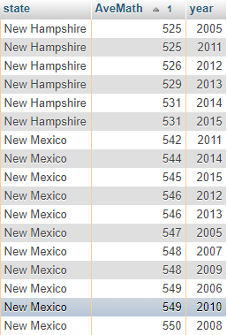

1. Display the top 5 Average Verbal scores, year, and GPA of Texas with a GPA of “A+”, “A-”, or “A.”

SELECT years.year, gpa_scores.score, gpas.gpa

FROM years, score, gpa_scores, states, gpas, types

WHERE years.yearId = score.yearsId

AND gpa_scores.scoreId = score.scoreId

AND states.stateCode = score.stateCode

AND gpas.gpaid = gpa_scores.gpaid

AND types.typeId = gpa_scores.typeId

AND state = "Texas"

AND gpas.gpa IN ("A+","A","A-")

AND type = "Verbal"

ORDER BY `gpa_scores`.`score` DESC

LIMIT 5

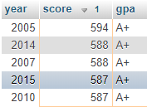

1. Show the States and average female math scores that are more than the average math score of males in all states on 2010.

SELECT state, gender_scores.score, gender_scores.typeId

FROM `gender_scores`, years, score, types, states

WHERE gender_scores.scoreId = score.scoreId

AND years.yearId = score.yearsId

AND types.typeId = gender_scores.typeId

AND states.stateCode = score.stateCode

AND year = "2010"

AND gender = "female"

AND type = "Math"

AND score > (

SELECT AVG(score)

FROM `gender_scores`, years, score, types, states

WHERE gender_scores.scoreId = score.scoreId

AND years.yearId = score.yearsId

AND types.typeId = gender_scores.typeId

AND states.stateCode = score.stateCode

AND gender = "male"

AND types.type = "Math"

AND year = "2010"

)

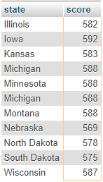

1. What Family income range has the most test takers in California on 2010.

SELECT family_income_range.min, family_income_range.max, score

FROM `Fam_income_scores`, family_income_range

WHERE Fam_income_scores.fiid = family_income_range.fiid

AND score = (

SELECT MAX(Fam_income_scores.score)

FROM `Fam_income_scores`, years, score, types, states

WHERE Fam_income_scores.scoreId = score.scoreId

AND years.yearId = score.yearsId

AND types.typeId = Fam_income_scores.typeId

AND states.stateCode = score.stateCode

AND state = "california"

AND year = "2010"

)



1. Show the state, average gpa, average verbal score for the highest average GPA in the subject of “Natual Science” for each year.

SELECT state, year, aveGPA, score.AveVerbal

FROM subject_averages, years, score, subjects, states

WHERE subject_averages.scoreId = score.scoreId

AND years.yearId = score.yearsId

AND states.stateCode = score.stateCode

AND subjects.subid = subject_averages.subid

AND (year, aveGPA, subject) IN (

SELECT year, MAX(aveGPA), subjects.subject

FROM subject_averages, years, score, subjects

WHERE subject_averages.scoreId = score.scoreId

AND score.yearsId = years.yearId

AND subject_averages.subid = subjects.subid

AND subject = "Natural Science"

GROUP BY year

)

GROUP BY year

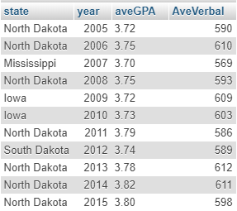

1. Show the Total number of male students that took the math test in each score range on 2013 that is greater than 100,000.

SELECT score_range.min as 'Score Range From', score_range.max as 'To', SUM(students)

FROM `score_range_students`, types, states, score, years, score_range

WHERE types.typeId =score_range_students.typeid

AND types.typeId = score.yearsId

AND states.stateCode = score.stateCode

AND score_range_students.scoreId = score.scoreId

AND score_range.srid = score_range_students.srid

AND gender = "male"

AND types.type = "Math"

AND year = 2013

GROUP BY score_range.srid

HAVING sum(students) > 100000

